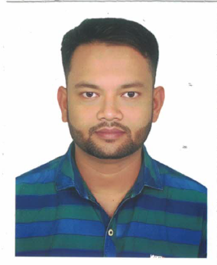 **CURRICULUM VITAE**

|  |  |
| --- | --- |
| PERSONAL INFORMATION |  |
| name | ABDUR RAHIM |
| address | SUJONDOAL, PALONG MODEL, KUARPUR – 8000, SHARIATPUR |
| TEL | +8801918177694 |
| E-MAIL | EDSB@ITALBANGLA.NET |
| nationality | BANGLADESHI |
| date of Birth | 01/11/1988 |
| gender | MALE |
| proffesion | SWING OPARETOR |
| marital status | SINGLE |
| driving license | NO |
| experience | 15 YEARS |
| technical training | |  |  |  | | --- | --- | --- | | organization | training name | duration | | . |  |  | |
| academic qualification | |  |  |  |  | | --- | --- | --- | --- | | EXAMINATION | INSTITUTE | RESULT | PASSING YEAR | | SSC |  |  |  | |
|  |  |
| SKILLS AND COMPETENCIES | RESPONSIBLE FOR STITCHING AND ASSEMBLING FABRIC PIECES TO CREATE GARMENTS USING INDUSTRIAL SEWING MACHINES. DUTIES INCLUDE OPERATING DIFFERENT TYPES OF SEWING MACHINES, FOLLOWING DESIGN SPECIFICATIONS, INSPECTING FABRICS FOR DEFECTS, AND ENSURING HIGH-QUALITY STITCHING. SEWING OPERATORS MUST HAVE STRONG HAND-EYE COORDINATION, ATTENTION TO DETAIL, AND KNOWLEDGE OF SEWING TECHNIQUES. ADDITIONALLY, FOLLOWING SAFETY REGULATIONS, MEET PRODUCTION TARGETS, AND MAINTAIN MY WORKSTATION CLEAN AND ORGANIZED. EXPERIENCE IN GARMENT MANUFACTURING AND THE ABILITY TO WORK IN A FAST-PACED ENVIRONMENT ARE ESSENTIAL FOR THIS ROLE. |
| LANGUAGE | BANGLA |
| ALTERNATIVE LANGUAGE | ENGLISH |
| INFORMATION TECHNOLOGY |  |
| ADDITIONAL INFORMATION | I AM A HIGHLY DILLIGENT AND SINCERE INDIVIDUAL. I STRIVE TO LEARN NEW THINGS QUICKLY AND POSSESS EXPERIENCE IN TEAMWORK AND EFFECTIVE COORDINATION WITH OTHERS. |
| ATTACHMENTS | COPY: PASSPORT, PROFESSIONAL COURSE CERTIFICATE, EDUCATION CERTIFICATE |

|  |
| --- |
|  |

SIGNATURE

DATE : 02/02/2025